English Martyrs' Catholic Primary School Newsletter
10th February 2017
Half Term Holiday – Monday 13th – Friday 17th 2017
Pupils return to school Monday 20th February 2017

We have come to the end of our first half term this year, thank you to all parent/carers for your support in your child’s education and towards the school. We wish you all a relaxing, safe and enjoyable half term.

School Home time Collection– Please make sure you call the school office by 2.30pm (latest) if you require someone other than yourself to collect your child from school. Please make sure the message is very clear to the office staff on who will be collecting your child. The class teacher will not allow pupils to be collected by someone different from a parent/carer if they are not informed by the school office prior to collection time.
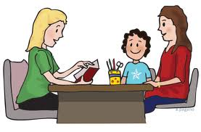
Parent evenings – Termly Learning Conference
Our Termly Learning Conferences will be held for Nursery – Year 5 Parents/Carers on 28th February and again on 7th March from 3.15pm - 6.00pm. Year 6 Parents/Carers meetings will be held on 28th February and again on 8th March. After half term, parents will be asked to make an appointment with your child's teacher to discuss your child's progress and their targets. It is very important that we meet with all parents, so please respond to the appointment letter.

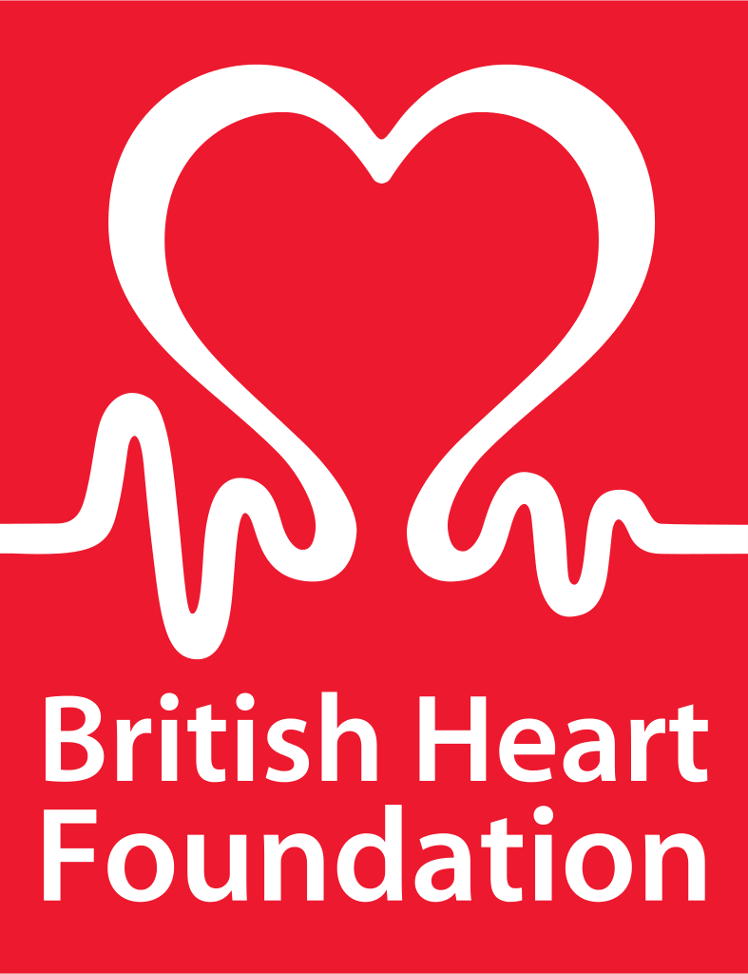
The British Heart Foundation – Pupils are invited to wear their own clothes on 1st March 2017 to help raise awareness for the British Heart Foundation; Pupils are asked to pay £1.00 each as a donation to the Foundation. This is linked with Book week and pupils in class will be learning more about the Heart Foundation and research into the causes and treatment of heart disease. Please use the links provided for more information and to continue to help raise awareness at home with your child and other family members.
- https://www.bhf.org.uk/heart-health
- https://www.youtube.com/watch?v=r4_fyuxzYwU
- https://www.youtube.com/watch?v=T2WF8B_5CsI
Bikeability – Year 3 and 4 will be taking part in Bikeability training in March, provided by Southwark. This is a great opportunity for pupils to learn the basic skills of bike maintenance and safety training whilst using their bikes around our busy community. It is very popular with pupils and we welcome back two specialised trainees to help deliver the training.

City Hall Visit – Year 5 will visit City Hall on 22nd March with a 2-hour visit in one of the committee rooms along with a presentation, a selection of short video clips, and a quiz and lots with of opportunities for questions and discussion. The visits are designed to:
- Enthuse Londoners about their city through our fascinating history and unique place on the national and global stage
- Explain the roles and responsibilities of the GLA, Mayor of London and London Assembly
- Develop an understanding of different political viewpoints and an appreciation of the importance of voting
- Give visitors confidence and encouragement to engage in political debates
- Encourage visitors to actively engage with the GLA

Annie - Year 6 had a wonderful time seeing the production of 'Annie' at Sacred Heart Secondary school during the week. They could not believe how professional the acting was and loved recognising some of our past pupils.

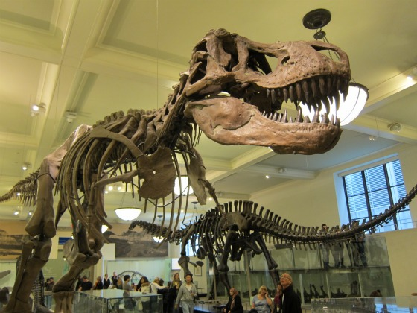
Natural History Museum - 2nd and 3rd of March, Year 3 will be attending the National History Museum to participate in the 'Dino scene' workshop. Students will be digging for fossils and examining what being a palaeontologist is all about. Students will be learning about the famous palaeontologist Mary Anning and her contribution to science. Mary Anning discovered the first Ichthyosaur, Plesiosaur and Pterosaur fossils.

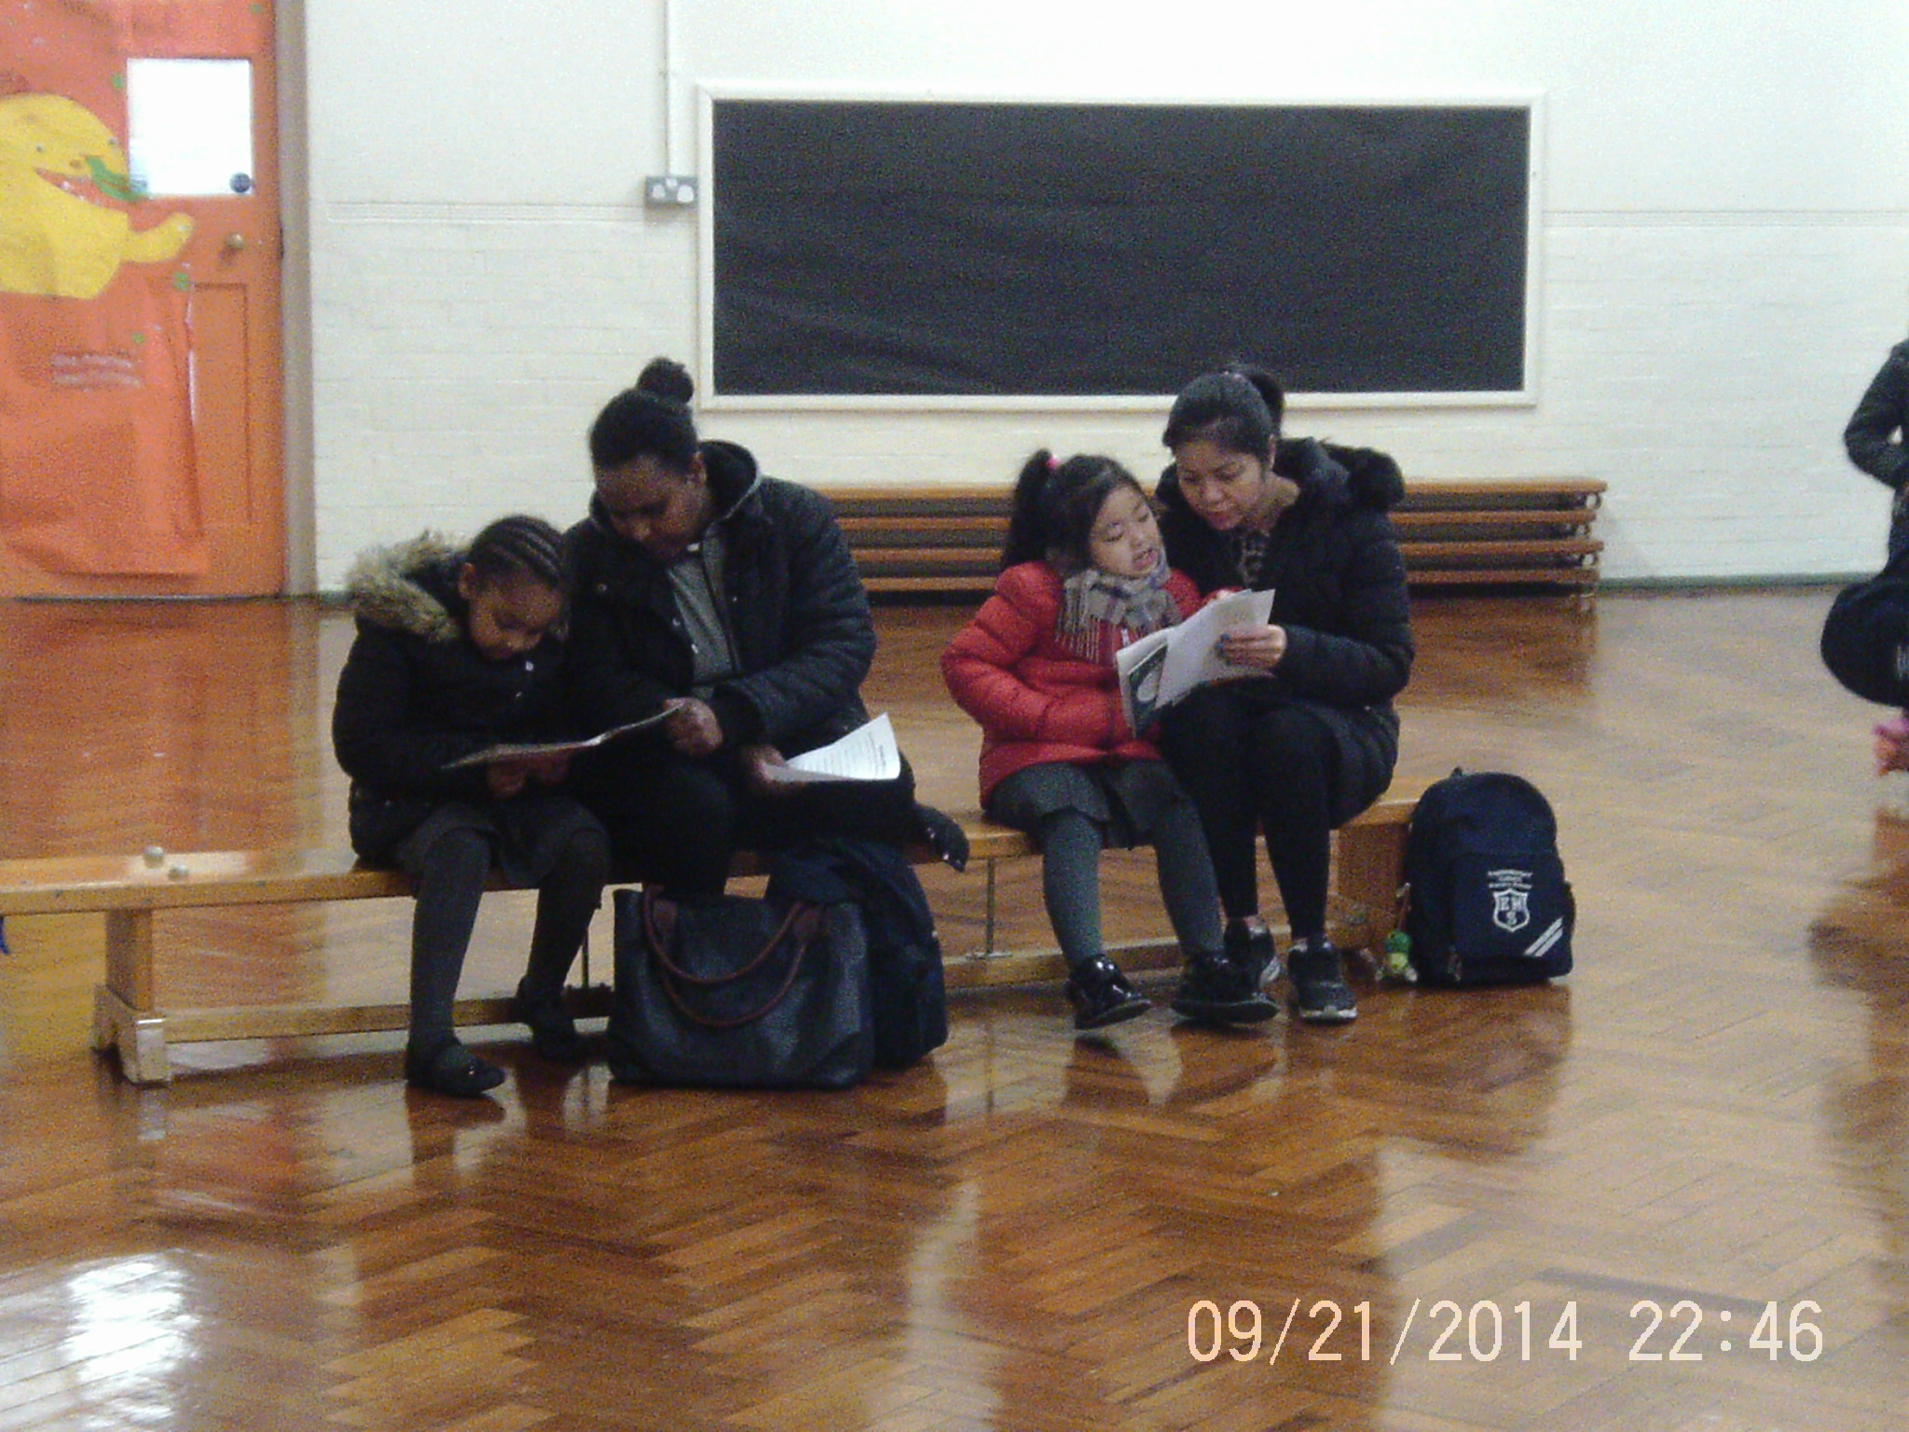

Early Years and KS1 Parents - Thank you to all parents who have been attending the ‘Read with your child” sessions every Wednesday morning. This will continue after half term on 22nd February, 1st March and 22nd March from 8.40am-8.55am.
Early Years Maths workshop - Mrs Bentaleb and Ms Mintram want to say a big thank you to all the nursery and reception parents who attended the early years maths workshop on Wednesday 8th February. Many ideas were shared about learning number and all parents should have received an Early Years Maths pack. Enjoy practising maths during the half term and finding number all around the environment.

Year 4, have been taking part in Westminster Cathedral outreach and are launching a children's choir (age 7 -11) where they will sing at mass (Saturday's 6pm once a month) please visit the link provided where more details can be found. https://www.victoriachildrenschoir.com. Mr Vonberg-Clark who is organising this event would love to have some children from English Martyrs’ take part.

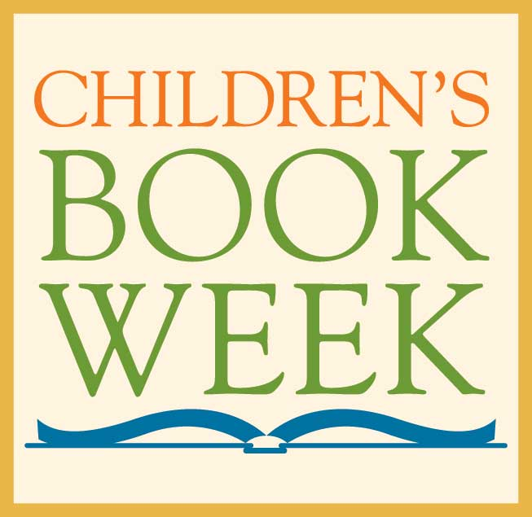
Book Week - We are celebrating Book Week during the week beginning 27th February and the theme is 'Stories from Around the World'. We will be celebrating different traditional tales from lots of cultures. As part of this week, and to raise money for the British Heart Foundation, children are invited to dress up as a character from a traditional story on Wednesday 1st March and bring £1 to school. There will be prizes for the best costumes!

We would also like to invite parents to come in and share any traditional stories from their cultures with the children. If you would like to take part in this, please speak to Miss Dellar.
Stars of the week – We are celebrating our pupils Good News achievements on our school website each week. Please go to Our Parents, dropdown menu to see Star of the Week, and check to see your child’s name is there, encourage your child to continue with their fantastic efforts throughout all aspects of the school

Y6 SATs Timetable
Children in Year 6 will be taking their SATs tests the week beginning 8th May.
Monday 8th May - Reading
Tuesday 9th May - Grammar and spelling
Wednesday 10th May - Arithmetic and Maths Reasoning 1
Thursday 11th May - Maths Reasoning paper 2
Writing is continuously assessed in school with final assessments being made in June.

It is important that children are doing all their homework to help them with their tests and all children need to be in school every day.
Y2 SATs
These will take place from the 15th May until the end of May.
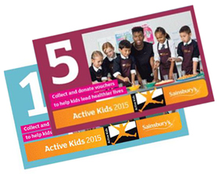
A workshop on KS1 SATs will be held on Wednesday 22nd May at 9.00am in building 1 (first floor hall).

Sainsbury Active Kids 2017 – Sainsbury’s are giving out vouchers with your shopping to help schools receive P.E. equipment and apparatus for schools. Please collect vouchers to help our school. Vouchers can be given to a member of the office staff or your class teacher.

Wishing you all a safe and enjoyable half term holiday. Please remember to listen to your child read as well as encourage them to log on to MyMaths.
God Bless
Mrs Appah

