English Martyrs' Catholic Primary School Newsletter
17th March 2017

Nursery Places – we currently have full time (all day) nursery places available and afternoon vacancies. There will be a charge of £12.00 per day for full time, inclusive of a hot lunch. Any enquires please speak to a member of the admin team or the School Business Manager.

Labour M.P. Visit – our local Labour M.P Mr Neil Coyle will be visiting our school on Friday 24th March to spend some time with our pupils and to learn about all the fantastic activities our children get up to.
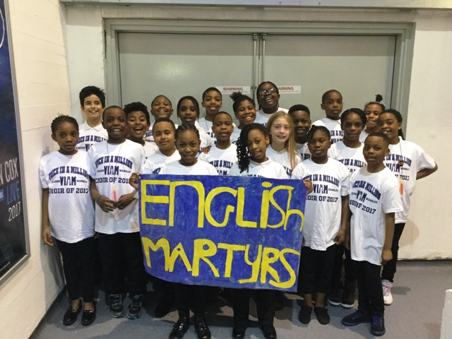
Voices in a Million- Ms Della’s choir performed brilliantly at the Voices in a Million concert at the iconic Wembley Arena on Wednesday 8th March. They sang and danced with lots of energy and really enjoyed the amazing experience of performing in such a famous venue. Well done to all of them and thank you to the parents who came to watch and support your children. Photos are available to view on our website photo gallery.

School Telephone – We have a new automated telephone service; you can now report your child’s absence by voicemail without having to wait to be put through to the main office.
Science Week (13th-17th March) - We held many exciting activities throughout the week linked to science. There was a poster competition and prizes for each year group, Years 1-5 had a special visit from the Science Wizard, a company who specialise in making science exciting for children. All the children learnt about science in a fun and exciting way. Please visit our Teaching & Learning - Science page for more information. Parents are invited to attend the science celebration assembly on 17th March at 2.30pm Bld 1 for Year 1 and 2, Bld 2 for years 3, 4, & 5.

Summer Fete 2017 - We will be hosting our annual summer fete in July, date to be confirmed, this is always an event that the pupils love and allows the school and parent/carers to all come together for a fun packed afternoon. There will be face painting, nail painting, beat the goalie, food stalls and lots of other fun planned activities. To help ease the pressure on staff and make this event run smoothly for all we would like to organise a Parent Teacher Association to recruit volunteers to help on the day. If you would like to put yourself forward to help please give your name to a member of the school admin team and a member of staff then please get in touch.
Budget Cuts – You may have already seen on the news that school budgets have been cut and that going forward things will be harder than the year before. This will have a huge impact on Southwark schools. A separate letter has been sent out to all parents, so please support our school and your children.

R.E. Week (27th – 29th March) - There will be many activities planned throughout the week for pupils from Nursery through to Year 6. Each year group will be visiting a place of worship and writing about their experiences. Classes will be taking part in creating their own Cross Tie-Dye t-shirts, please see link on instructions if you wish to do this at home https://www.youtube.com/watch?v=gm6G7qMom4s as well as painting the Stations of the Cross in their art lessons. Parents will be invited to attend a special R.E. assembly, dates and times will be announced soon.

RELIGIOUS CORNER
Saint Patrick is the patron saint of Ireland. He was a Christian missionary given credited with converting Ireland to Christianity in the AD 400s. So many legends surround his life that the truth is not easily found. He was set the task of teaching Christianity to the Irish. He travelled throughout Ireland, preaching the Gospel and converting many. He and his disciples preached and converted thousands and began building churches all over the country.

Important Religious Dates this term
ST JOSEPH, SPOUSE OF THE BLESSED VIRGIN MARY - 20 March
THE ANNUNCIATION OF THE LORD - 25 March
PALM SUNDAY OF THE PASSION OF THE LORD - 9 April
MAUNDY THURSDAY - 13 April
GOOD FRIDAY - 14 April
EASTER SUNDAY -16 April

Dates for your diary
Easter Holidays
Inset Day 31st March 2017
Last day of term for pupils 30th March
School close 31st March
Pupils return Tuesday 18th April

Southwark Council with Cycle Confident are providing
FREE cycle training for children over the Easter holidays
Posters advertising this are on display at the school entrance or please click on the link provided for more information
BOOK NOW
Places are limited so for more info or to book, visit
www.cycleconfident.com/sponsors/southwark
or calling 020 303 16730

Parent Alert
There has been an incident report regarding an attempted abduction near Elsie Road, East Dulwich this week. A White man in a black car got out and tried to pull a year 6 girl by her cardigan sleeve. Fortunately, the young girl ran to school and reported the incident. Please take extra care, be vigilant, and speak to your children if they are out alone.

Well done to all those that achieved a Good News Certificate this week, check to see their names on the Star of the Week page on our website

Millwall Supporters Fun Day
Millwall are excited to offer supporters a pre-match Family Fun zone day ahead of this Saturdays Match. Events start at 1pm-2pm. A copy of the letter was emailed to parents, there will be many exciting activities for you to enjoy
Please continue to support your child’s learning at home by logging on to MyMaths regularly and listening to your child read each evening,
Practise testing then on their times tables and spellings
Wishing you all a relaxing, healthy and safe weekend.
God Bless
Mrs Appah

