

**English Martyrs' Catholic Primary School Newsletter**



**1st July 2016**

**Maths Week:**

Next week starting Monday 4th July is Maths week.  Our theme for this year is **MATHS IS EVERYWHERE**.  We will be learning about how Maths is used in so many different ways, everywhere not just at school!  Children will be taking part in Maths workshops, using lessons in other areas of the curriculum and taking part in maths competitions.

To Divine, Michael, Danil, Isayande, Mia, Tracey,Frankie, Kiara, Ayomide, Joshua and Sophia who all made their First Holy Communion in English Martyrs’ Church on 29th May 201. May God continue to bless you and your families.

**PARENTS - Maths Week**

On Friday 8th July, Parents are invited to come and have a look at our Maths Workshops led by Year 6 pupils.  These will take place in Building 1 Top Hall from 2.45pm onwards.   We also invite parents to support our Maths week by looking for opportunities where they can discuss maths examples with children in different contexts at home etc.

**Safeguarding**

Children’s welfare and safety is paramount in our school. At English Martyrs’ we have a safeguarding team that deal with issues of safety and welfare. Our Designated Safeguarding Lead is Mrs Appah, our Deputy Leads can also deal with any concerns and this includes all our senior leaders.

**Prevent Duty**

Most of you will know from the media, that schools now have a duty to prevent children from radicalisation. The Designated Person for Prevent is Mrs Appah. Please report anything you notice or hear which may be of concern and require investigation to Mrs Appah

**E-Safety**

The school’s Designated Person for E-Safety is Mr Young. E-safety is very important, if your child experiences any problems, or you have concerns please contact Mr Young

**If your child is unwell**

If your child is unwell with sickness and diarrhoea, please keep them at home until they are completing better. This means that you need to wait until there has been no vomiting or diarrhoea for at least 24 hours. Illness of this kind spreads very quickly, especially in very young children.

**Clothing Needed**

We would be grateful to have donations of spare items of uniform and if possible new underwear, particularly for the younger children, to be kept in our medical room. When we have used items of spare uniform, it is not returned, leaving us very short on helping others that may need it.

**Medication Kept at School**

If we have medicines at school for your child’s medical condition (e.g. Asthma, Anaphylaxis) please make sure the office has a completed medical form. Thank you to all parents that have completed the form required by the school. If you have not done so, please ask for a copy from the office. Please check the dates on your child’s medication. This is very important, out of date medicine’s may not be effective and will need to be disposed of.

**Contact Numbers**

It is extremely important that you keep your child’s contact details up to date. If your child has an accident or is taken ill at school, we need to be able to contact you immediately.

**Labelling School Uniform**

Please make sure that your child’s different items of school uniform are labelled clearly with their name. This can be done easily with waterproof pen or labels stitched into the collar or side seam of each item of clothing. This will make it a lot easier to return the lost item to the correct owner.

**Transition Meeting – Moving from Nursery to Reception**

Parents are invited to a meeting on Monday 4th July at 3.30pm.



**P.E. and Health Week**

Thank you to all the parents that supported our Health and Sports Week

by attending sports days and the various workshops on healthy living. Year 3 & 4 sports day will be held on Wednesday 6th July.

**Year 6 – Splash Performance - Royal Festival Hall**

Year 6 have been working very hard towards their performance, which will be held on 5th July at the Royal Festival Hall. They are very excited, and visited St Saviours and St Olive’s secondary school on Friday 1st to practice with the many other schools in Southwark taking part in this event. Parents and staff have purchased tickets to watch the performance and from previous years, we know it is a wonderful evening of entertainment. We are very proud of our year 6 pupils and wish them lots of luck on the night.



**Bikeability Training**

Year 6 pupils will receive their Level 1 & 2 Bikeability Training on Monday 4th July. Two representatives from Southwark will be in school on Monday, Wednesday, Thursday and Friday to help the pupils learn safe bike and road skills.

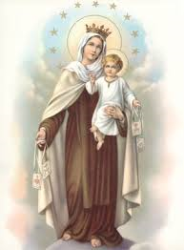

**Whole School Mass**

**Our Lady of Mount Carmel**

The whole school will come together on 15th July to celebrate our Lady of Mount Carmel in our Parish Church. We welcome Parents and Carers to join us.

***Congratulations***

Congratulations to Mrs Kakande who gave birth to a beautiful, healthy baby boy, named Isaac. God bless her and her family.

Thank you to all parent / carers that have already donated to the school for the summer fete. Raffle tickets are now on sale before and after school as well as on the day.

Posters have been placed around the school advertising the prizes. We are still accepting donations and we thank you for your support.



**Sports Day**

Years 1 & 2, and Years 5 & 6 took part in their sports day as part of P.E. week. Thank you to all the staff involved in helping prepare the activities and to the parents/carers that attended to support their children and who joined in with the Parents race. We have some very fast parents!

All the pupils had a great time and displayed some wonderful team spirit.

Well done to all everyone.

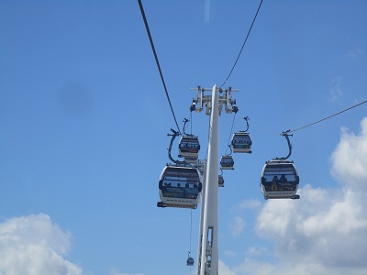

**Reception Transport Trip**

Reception classes had a great day out, using various public transport as part of their topic. They travelled by Bus, journeyed along the River Thames on a boat and went high up to see the sights of London on the Cable car as well as getting to witness an Aeroplane landing and taking off at City Airport. Thank you to all the parents/carers that attended the trip as support to the class teachers. There are some photos available to view on our school website in the gallery page.

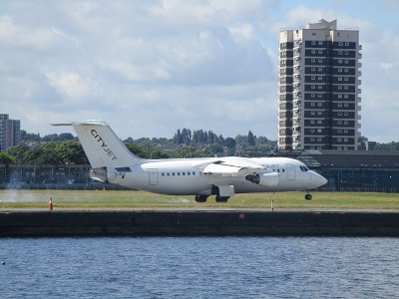

**September Intake - Nursery**

We are still accepting applications for Nursery places in September 2016. Please visit the school office for an application.

**Head Teacher’s Message**

Thank you to all the Parents/Carers and staff for all their hard work to help support, encourage and enable the pupils to achieve their best at English Martyrs’ School.

Wishing you all a safe and happy weekend.

God Bless

Mrs Appah