** English Martyrs' Catholic Primary School Newsletter**

**28th April 2016**



**SATS Information** SATs for Year 6 begins on the **8thth May and finishes on 11th May**.

This is a very important time for Year 6 and they have been working very hard. Please make sure your child is in school EVERY day. There will be Breakfast Club for Year 6 pupils that week and it is recommended all Year 6 pupils attend at 8.00am, to enjoy a healthy breakfast and feel relaxed before their tests.

**This is for Yr 6 pupils only, there is no provision for any siblings so please do not send them in to school at 8am**

Year 2 SATs will take place throughout the month of May. All pupils are working very hard and we wish them Good Luck, more information will follow and parents will be informed.

Pupil Collection Notice - The school will not allow family members or friends to collect your child at the end of the day unless the parent has contacted the school office and spoken to the office staff to inform them who will be collecting their child. Teachers will then be notified. If the office / teachers have not been informed of the alternative arrangements, your child will have to wait in the school until the Parent/Carer arrives and this will be recorded as a late collection. All staff must follow this safeguarding procedure. We ask that parent/carers support the school. Our staff in entering our Safeguarding Policy should not have to deal with rude behavior. This is unacceptable and will not be tolerated.

Late Collections – Please make sure you drop and collect your child each day on time. Pupils can become upset if they are late. Late collection affects our staffs, who will have to stay beyond their contracted hours, which is unfair on our hardworking and committed staff. Consistent late collection will result in a meeting with the Head Teacher and possible fines being given in accordance with our charging policy.

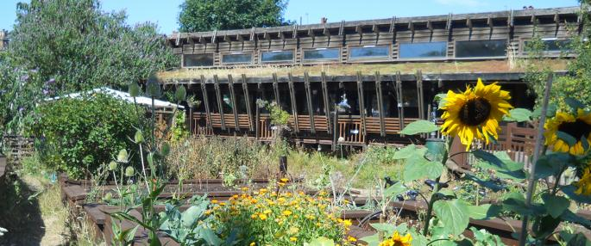School Trips – **Year 5** visited Deptford Creek Discovery Centre to reinforce their science and humanities knowledge and to gain a better understanding of rivers and their habitats.  The children will explore the features of a river; find out about habitats within the river system and test samples of river water to determine if it is clean and a suitable habitat. Photos of their trip will be available to view on our photo gallery website soon.

**Year 4** visited the Centre of Wildlife to learn to identify wild animals and their habitats.

**Year 3** will be visiting the National Museum to take part in a workshop and learn more about the Stone Age as part of their class topic.

There will be more exciting educational trips planned throughout the term and will keep you posted.

Free workshops in Southwark for parents – ever wanted to try to learn a new skill or enhance one you may already have. Southwark are offering courses from Gardening to Yoga, click on the link provided to find out more and take advantage of this wonderful offer. <http://www.walworthgarden.org.uk>

Summer Uniform - We hope that the sun returns soon! We would remind you about our summer uniform, blue or yellow summer dress (no shorter than knee length) and socks, (white or grey) (no tights), Grey shorts for boys. It has been noticed that some girl pupils are wearing small-hooped earrings. These are not allowed but small plan studs are acceptable. Pupils will be asked to remove hooped earrings if seen.

Millwall Free Tickets- We have been given tickets to the Millwall Lionesses last game of the season. All are welcome to go to this event; children must be accompanied by an adult.

These tickets are completely free; all you have to do is follow the instructions below.

 When buying tickets, select 1 person in your party, enter the code below and then do the same again. There is no specific seating structure so you will be able to sit with your party.

**Venue:** Fisher FC, St Pauls Sport's Ground, Salter Road, London, SE16 5EF

**Kick off**: Sunday 30th April, 2pm

Please print your tickets off and show them at the gate on entry.

Instructions;

1.       Go to <http://bit.ly/LionessTickets>

2.       Select the game v Doncaster Belles

3.       Enter code Mill4All in the Promotional Code column as per below

**R.E. Thought for the week**

[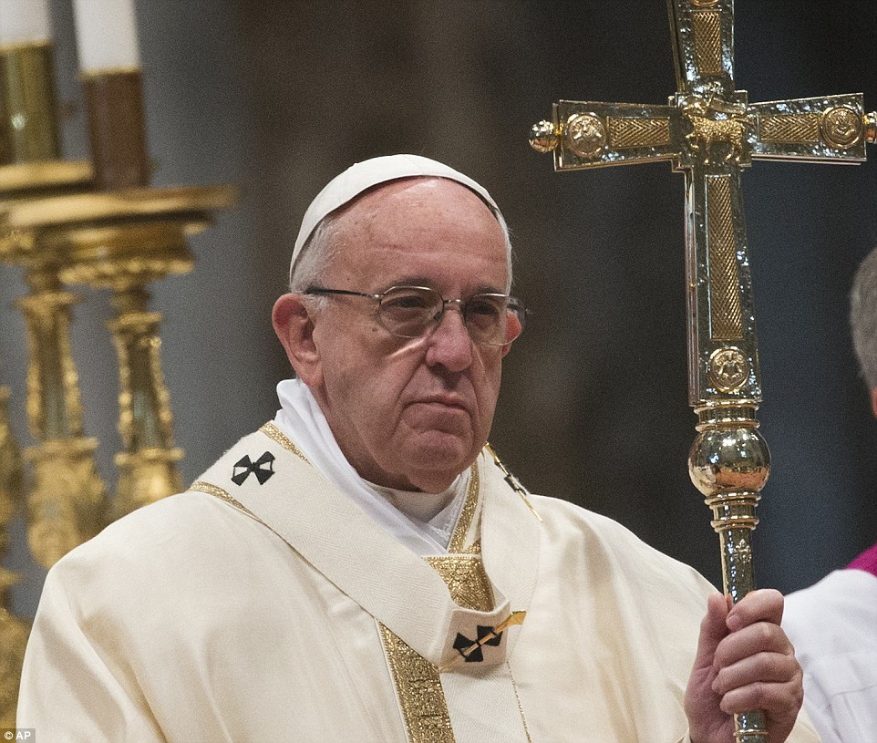](http://www.google.co.uk/url?sa=i&rct=j&q=&esrc=s&source=images&cd=&ved=0ahUKEwif-OPHqMfTAhUGwxQKHS4XAssQjRwIBw&url=http://www.dailymail.co.uk/news/article-3500069/Pope-Francis-ordains-new-bishops-service-Vatican.html&psig=AFQjCNESLiK5mukUU1rvic_mE0CaSG5XYQ&ust=1493474286726125)

*“This is important: to get to know people, listen, expand the circle of ideas. The world is crisscrossed by roads that come closer together and move apart, but the important thing is that they lead towards the Good”*Quote from Pope Francis

**Pope Francis** was born on 17th December 1936 and is the 266th Pope of the Roman Catholic Church.

Throughout his public life, Pope Francis has been noted for his humility, emphasis on God's mercy and concern for the poor.

Please could we draw your attention to our Faith page on the website? This includes our Mission Statement and our Core Values together with copies of our informative R.E. Newsletters. We will be adding more in due course so keep checking.

**Wishing you all a safe and restful Bank Holiday weekend, remember to read with your child and support them with their learning.**

**Pupils return to school on Tuesday 2nd May 2017**

**God Bless**

**Mrs Appah**