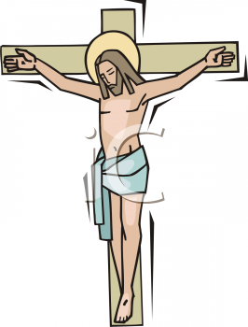
English Martyrs' Catholic Primary School Newsletter
30th March 2017

Dear Families,
We have completed another term and thank all pupils and staff for all their hard work. It has been a very busy term with lots of exciting events happening.
Children return to school Tuesday 18th April 2016

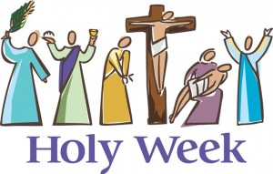
R.E. Week (27th – 29th March) – This week the whole school took part in R.E. week celebrations. There were many fun and exciting activities planned for pupils from Nursery through to Year 6. Each year group visited a place of worship and have been writing about their experiences. Classes took part in creating their own Cross, Tie-Dye t-shirts, please see link on instructions if you wish to do this at home https://www.youtube.com/watch?v=gm6G7qMom4s as well as painting the Stations of the Cross in their art lessons. Parents were invited to attend a special R.E. assembly
Learning about other Faiths – As part of R.E. week and as part of the R.E. Curriculum we learn about other Faiths, their core beliefs and practices, to enable to us to teach our pupils respect and understanding of world religions. All year groups have visited a Catholic Church, a Church of England Church a Buddhist Temple, a Hindu Temple, a Jewish Synagogue and a Mosque. Please see below the places of worship that each year group visited.
Reception Classes | English Martyrs’ Church, Walworth | Year 2 | Jamyang Buddhist Temple
Year 1 | St Peters Church, Walworth | Year 3 | Bevis Marks Synagogue
Year 4 | Gurdwara Sikh Sangat | Year 5 | Maha Lakshmi Vidya Bhaven
Year 6 | Baitul Aziz Islamic Cultural Centre

Congratulations – Pupils from Year 3 attended auditions last week for the opportunity to participate in the Chance to Dance programme at the Royal Opera House. A quote from the Chance to Dance Team - “The Chance to Dance team have thoroughly enjoyed working with your school over the past few months, delivering the Chance to Dance, in-school projects. We hope all your year 3 classes have enjoyed the experience”. Please see below the names of those children who have been selected to go through to the Chance to Dance Company, and those children who are on the reserve list. We are very proud of all the pupils and wish them luck.
Selected | Reserves
Hadi, Levon | Matthew
Vera, Esseosa | Chidera

EMS Chicks – Year 1 helped nurture and protect eggs brought to the school from Surrey Docks Farm and became very proud carers of 6 baby chicks that were returned to Surrey Docks Farm on Friday 24th March. Thank you to Ms Shields, Ms Terry and all the pupils for their hard work and care shown in looking after the eggs and learning about their development. Photos can be viewed on our school website of the pupils looking after the eggs and the chicks growth.
Neil Coyle M.P. Visit – Mr Coyle visited the school on Friday 24th March and I would like to say a big thank you to all staff and pupils for their hard work in making this visit such a success. Mr Coyle visited all the classes and met with the pupils and staff. He had a very inspiring discussion with Year 6 pupils on his decision to become a M.P. Southwark News took photos of the visit, so remember to look in the paper for us on Thursday 30TH March edition. Pictures are also available to view on our website.
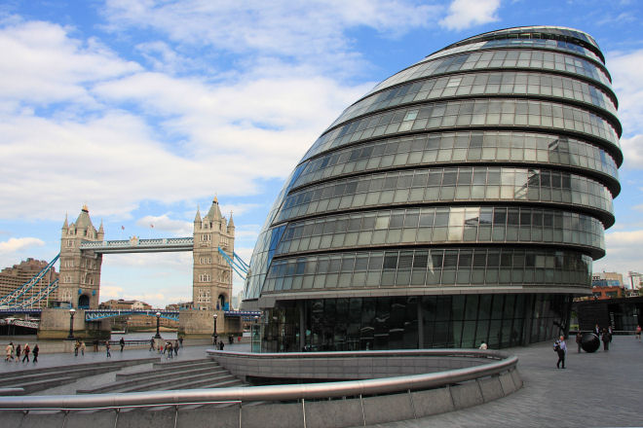
Class Assembly - 2J have had a wonderful 2 weeks to end the term. They visited the Jamyang Buddhist temple and learnt many interesting things about Buddhism. Although they were disappointed not to go on our National Gallery trip, they were really sensible and didn't complain at all! They used their extra time in class to do some writing about Raphael's painting 'The Crucifixion' and are looking forward to seeing it in real life after Easter.
City of London Visit - Year 5 visited The Mayor of London offices on Tuesday 21st March where they got to be part of the audience and witness a debate with Sadiq Khan. We would like to thank the staff for their fantastic efforts that day in ensuring the pupils felt safe after the very sad events that took place at Westminster. Our thoughts and prayers are with those that were injured and the families of those that lost their lives.
Booster Easter Sessions - Some Year 6 children have been invited for Easter School on Tuesday 4th April to Thursday 6th April from 9.15am to 2.30pm. These booster classes are very important for your child’s preparation for their SATs in May. Please remember to be punctual and have a packed lunch and a drink. Children should be picked up promptly at 2.30pm.

Y6 SATs Easter homework - As the SATs for Year 6 take place on May 8th (a couple of weeks after the Easter holidays) please ensure that children don't forget all the learning they have done over the year. All Year 6 children have been given a programme of revision for the holidays. This includes ten days of maths revision, five arithmetic tests, a grammar leaflet to learn all the grammatical terms for the test, the irregular spellings for Y3/4 and Y5/6 and nine short reading comprehensions. Please support your child’s learning leading up to this important period.

Breakfast club/Y6 SATs tests - Children will be invited to have a relaxing breakfast with their friends during the week of SATs. This enables them to eat a hearty breakfast of cereal, toast, fruit and juice before taking the tests and ensures that they do not get anxious before school. Children should come in between 8am - 8.15am on Monday May 8th, Tuesday May 9th, Wednesday May 10th and Thursday May 11th. The schedule for Y6 SATs is:

​Monday 8th May | ​ Reading Comprehension
​Tuesday 9th May | ​ Grammar, Punctuation and spelling
​Wednesday 10th May | ​ Arithmetic, Reasoning Paper 1
​Thursday 11th May | ​ Reasoning Paper 2
All tests begin promptly at the start of the day following a quick revision session.

Y2 SATs - Will also take place during May, but do not need to be undertaken on the same day by all children as they will be undertaken in small groups. Please ensure that children are in school every day.
It is that time of the year again when the evenings are staying lighter for longer. Please ensure that you and your family remain safe and we hope the sunshine continues.
Important Religious Dates this term
PALM SUNDAY OF THE PASSION OF THE LORD - 9 April
MAUNDY THURSDAY - 13 April
GOOD FRIDAY - 14 April
EASTER SUNDAY -16 April

Please continue to support your child’s learning at home by logging on to MyMaths regularly and listening to your child read each evening,
Practise testing then on their times tables and spellings
Wishing you all a relaxing, healthy and safe holiday.
God Bless
Mrs Appah

Well done to all those that achieved a Good News Certificate this term, for this week’s achievements please look on the Star of the Week page on our website

