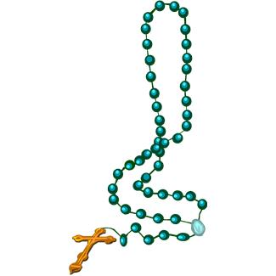
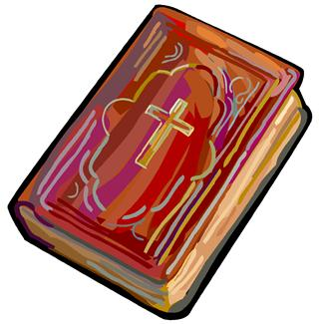
Eucharistic Liturgy

Friday 4th May | Readings  Yr 5T, S. Asaph | Group A  1J & 5T
Friday 12th May | Readings  Yr 5C, St Achilles  St. Nereus, St Pancras | Group B  1E & 5E
Friday 19th May | Readings  Yr 6, St Dunsvan | Group A  2K & 6T
Thursday 25th May | Readings  Yr6 (Ascension) | Group B  2L & 6M

HALF TERM
29th May – 2nd June

9th June | St Ephrem etc | Group A  3M & 6T
16th June | St Richard of Chichester | Group B  3C & 6M
23rd June | Sacred Heart of Jesus | Group A  1J & 4G
30th June | First Martyrs of the Church of Rome | Group B  1E & 4J
7th July | First Friday | Group A  2K & 6T
14th July | St Carmillus | Group B  2L & 6M
20th July | YR 6 Leavers Mass | Year 6
21st July | Whole School Mass | Yr 5

Group A | Group B
1J, 2K,  3M, 4G,  5T & 6T (Ms Kakande) | 1E, 2L,  3C, 4J,  5E, 6M (Ms Hughes)

