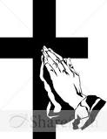English Martyrs’ Catholic Primary School R.E Newsletter

**12th January 2016**

Dear Parents,

I hope that you had a wonderful Christmas and New Year break. I wanted to thank you all for your generosity and kindness in donating items of food last month, and considering the less fortunate, in preparation for the birth of Our Blessed Lord. I am delighted to report that the response to our appeal was overwhelming, and we were able to give Father Tom a vast amount of food to distribute within the parish and local community, to those in need at Christmas. The children offered their gifts of food during Holy Mass on 18th December and I was very pleased that so many of you were able to join us.

[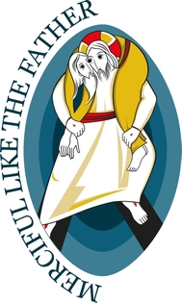](https://www.google.co.uk/url?sa=i&rct=j&q=&esrc=s&source=imgres&cd=&cad=rja&uact=8&ved=0ahUKEwjvrajsvpXKAhXFPhQKHSd_A5IQjRwICTAA&url=https://en.wikipedia.org/wiki/Extraordinary_Jubilee_of_Mercy&psig=AFQjCNHFsvy_bTJUHNgggxKu9IStR0Gmrw&ust=1452180173390105)At the end of last term, we were all very proud of the children’s Christmas performances and I hope you were able to see your child perform with their class. The Christmas Carol concert was well attended by both staff and parents; our school choir treated us to a variety of Christmas hymns and music from around the world. I would like to thank Miss Dellar for all her hard work in coordinating the concert, which was enjoyed by all. We all enjoyed the refreshments which were provided in the school hall.

**Loving Father,**

**Thank you for sending us your son Jesus to show us how much you love us and to show us how we should love each other.**

**Remind us to treat everyone we meet with love and care because they are your child too.**

**Send us your Holy Spirit to help us forgive people when they upset us, and to say sorry when we upset each other.**

**We ask this through Jesus Christ our Lord, Amen**

As you may know, Pope Francis has declared this Jubilee Year as the Year of Mercy. The year began on December 8th, the feast of the Immaculate Conception, when Pope Francis passed through the door in St Peter’s Basilica in Rome. Pope Francis tells us that, “Jesus Christ is the face of the Father’s mercy. These words might well sum up the mystery of the Christian faith.”

Our participation in the year of Mercy begins with a special, whole school focus on the parables where Jesus demonstrated mercy to mankind. All year groups will reflect on a particular parable and the ways in which Jesus Christ is indeed the face of the father’s mercy. All classes have been given a special intentions booklet, in which children will be invited to include their own special intentions and requests as we encourage them to trust in God’s never ending love and kindness. Pupils will also receive their own prayer card, in commemoration of the Year of Mercy. They will have opportunities to pray together in school but I would ask you to pray at home with your child, learning the special commemorative prayer as a family.

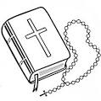During this half term we will focus our assemblies on the core value of compassion, and explore ways in which we may demonstrate compassion and mercy to others, following the example of Christ our Saviour. I do hope you will join us in reflecting on ways in which we may be merciful like the Father, and take time to pray at home with your children, saying our special prayer.

Yours sincerely,

Mrs Pennacchia

Deputy Head Teacher