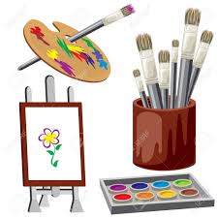
Inspiring Creativity
Please see below pictures of children’s Artwork

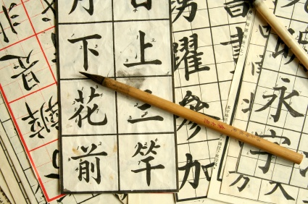

Year 1 will be looking at China for Geography this term. For art children will be introduced to calligraphy and willow patterns as well as making Chinese lanterns.

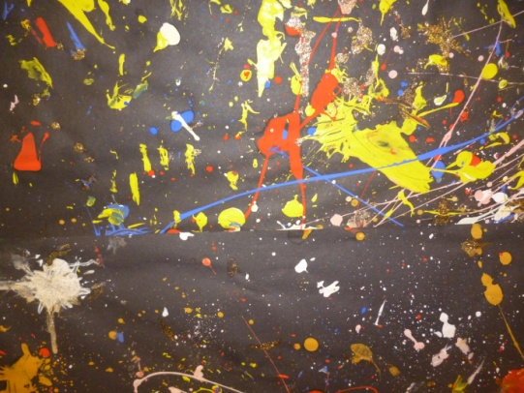
Year 2 have produced some lovely paintings of fireworks based on Jackson Pollock. Their focus has been on introducing the different colours in the colour wheel to the children.

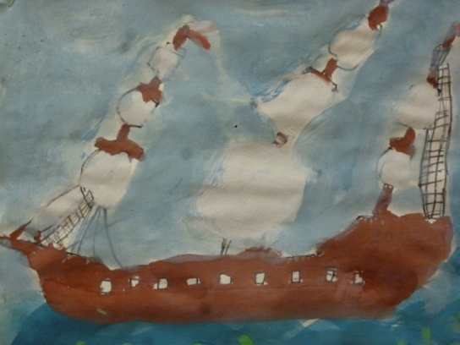

Year 3 and 4 have been looking at tribal tales and invaders and raiders. Year 3 have produced some paintings based on observational drawings of a pirate ship.

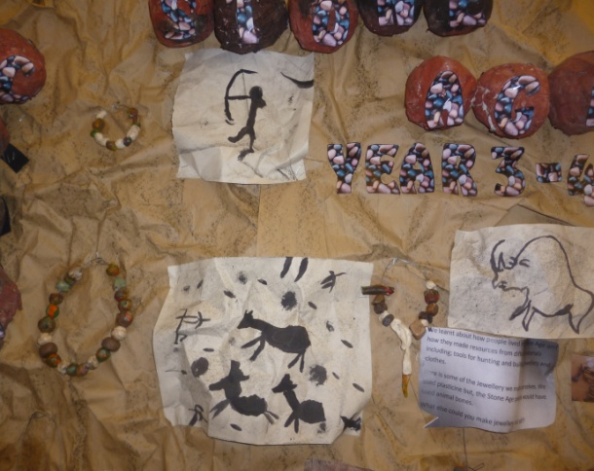
Year 3 and 4 have painted their own cave paintings using simple lines. They have also studied different artefacts found at burial sites and have reproduced these.

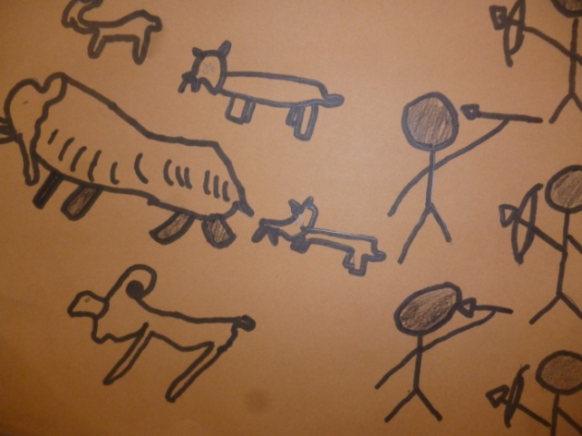

Year 3

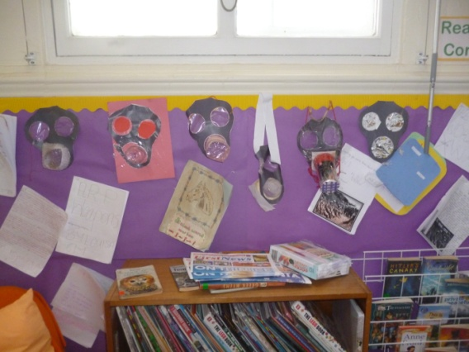
Year 6 made their own gas masks for their worlds war two project.

