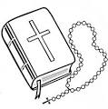

English Martyrs ‘

Catholic Primary School

**RE Newsletter 5**

SUMMER TERM 1

Dear Parent/Carers,

As we return to school, the Church is celebrating the great feast of Easter – Jesus risen from the dead. This celebration goes on until the solemnity of Pentecost (Sunday 4th June), the birthday of the Church. At Pentecost we celebrate the outpouring of the Holy Spirit who empowers and enables us to follow in the footsteps of Jesus. The half term ends just before the Ascension. During this half-term the Church dedicates the month of May to Mary, Jesus’ mother.

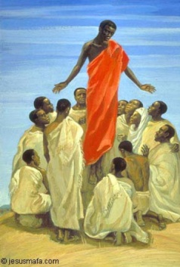We hope, as always, you find this newsletter interesting and informative. Please keep us in your prayers as we support your children in their Religious Education.

The Ascension 28th May

Dates from the Church’s calendar:

|  |
| --- |
| 16th April Easter Sunday4th May The English Martyrs  23rd April Second Sunday of Easter 7th May Fourth Sunday of Easter  24th April St. George, Patron of England 13th May Our Lady of Fatima  25th April St. Mark, Evangelist 14th May Fifth Sunday of Easter  30th April Third Sunday of Easter 25th May St. Bede  1st May St. Joseph the Worker 27th May St. Augustine of Canterbury  3rd May Ss. Philip & James, Apostle 28th May The Ascension of the Lord |

**Nursery and Reception— New Life**

**“Jesus’ life, death and resurrection are the central event of all human history and at the heart of faith”**

*Religious Education Curriculum Directory*

This half term, the children in the Nursery and the Reception classes will be learning about new life. They will learn about the story of the empty tomb, and learn that Jesus appeared to his disciples. The children will begin to understand the special gift of joy and peace that Jesus gave to his friends (John 20: 19-21) and can give to us as well. They will hear the story of Jesus going back to his Father and learn that one day we shall hopefully go there too.

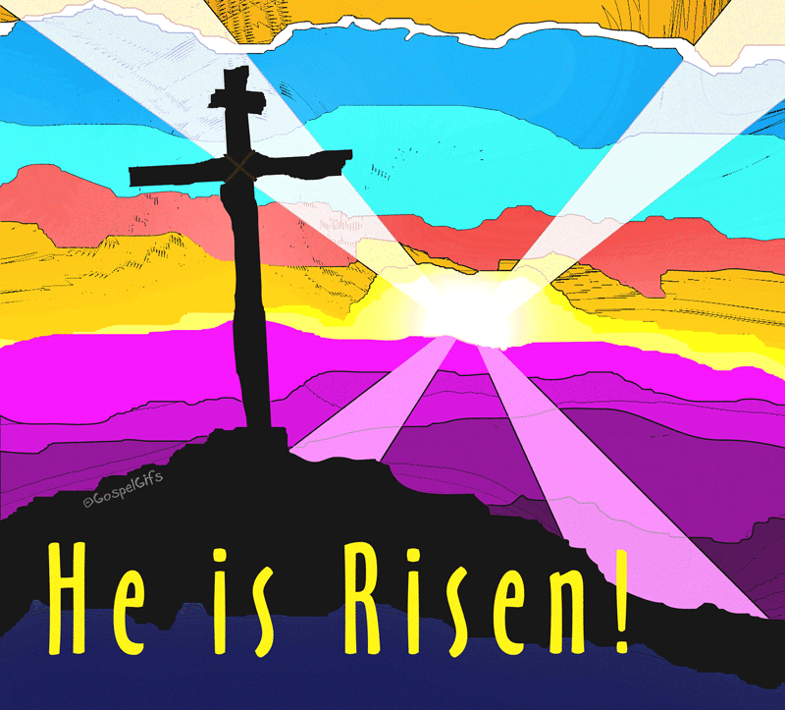

|  |
| --- |
| At home you could help your children by:  • planting an Easter garden  • looking for signs of new life  • practise the Sign of the Cross, ‘Our Father’ & ‘Hail Mary’  • encouraging them to write their own prayers |

**Year 1—The Resurrection**

**“Jesus’ Resurrection … is the source of our future resurrection: Christ has been raised from the dead, the first fruits of those who have fallen asleep. For as in Adam all die, so also in Christ shall all be made alive.”**

*Catechism of the Catholic Church*

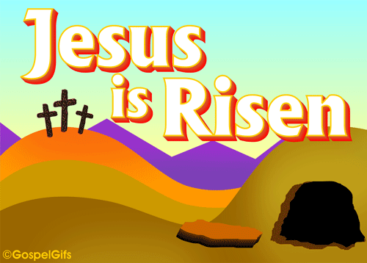Year 1 will learn that Jesus appeared to his disciples in the Upper Room and will think about the times when they have experienced great joy and surprise. They will learn that Jesus helped his disciples to understand that he was risen from the dead and was with them (John 21: 9-14) and this made them very happy. They will learn that when Thomas heard that Jesus was alive he did not believe it. They will also become aware that sometimes, like Thomas, we don’t understand what is happening.

|  |
| --- |
| At home  You could help your children by:  •reading stories from the Bible about Easter and Pentecost |

**Year 2—Eastertide**

**“It is the Holy Spirit who forms and guides God’s people to know God and enter into communion with God through Jesus Christ.”**

*Religious Education Curriculum Directory*

Year 2 will learn that Jesus rose from the dead and still lives with us. They will learn that Jesus told his disciples that he would go back to Heaven but promised that the Holy Spirit would come. They will learn that Jesus ascended into Heaven and promised to return again and that this gives us hope. They will also know the story of the coming of the Holy Spirit on the apostles at Pentecost and know that the Holy Spirit is promised to us.

|  |
| --- |
| At Home  You could help your children by:  • talking about how the Holy Spirit helps us   * Having a close look at the Paschal (Easter) Candle when at Mass |

**Year 3—Celebrating Easter & Pentecost**

**“God’s Self-Revelation is perfected in us by the Holy Spirit, the Spirit of truth, promised by Jesus and revealed at Pentecost.”**

*Religious Education Curriculum Directory*

Year 3 will learn that God the Father raised Jesus from the dead on Easter Sunday. They will learn that because Jesus rose from the dead we too will rise from the dead. They will hear the story of the appearance of Jesus on the road to Emmaus and to Thomas. They will also hear and reflect on the story of the coming of the Holy Spirit at Pentecost.



|  |
| --- |
| At Home  You could help your children by:  • talking to them about how the Church celebrates the resurrection  • reading the story of Pentecost with them  • discussing with them what they would have felt if they were one of the Disciples. |

**Year 4—The Mission of the Church / The Early Christians**

**“Through the Church Christ fulfils and reveals God’s plan to unite all things in him. Christ gave his Church a structure in calling and choosing twelve apostles. With them and their successors he shares his mission, his power and authority. In the coming of the Holy Spirit at Pentecost the Church was revealed and its mission to the nations was begun… The ultimate purpose of this mission is to share in the communion of life and love of the Father, Son and Holy Spirit.”** *Religious Education Curriculum Directory*

Year 4 will learn that Peter was chosen by Jesus to play a special role in the Church and that Jesus gave his followers a mission – to spread the Good News to others. They will learn that Jesus promised the Holy Spirit to help his followers and that Pentecost was the beginning of the Church. They will learn about the missions of Peter and Paul and about Stephen the first martyr of the Christian

faith.

|  |
| --- |
| **At Home:**  You could help your children by:  • discussing with them the life of St Peter and that he was the first Pope  • reading the missionary journeys of St Paul in Acts of the Apostles (Ch 16 ff)  • visiting www.tere.org/interactive_site/KS2link |

**Year 5—Life in the Risen Jesus**

**“Prayer is a living relationship with God in, with and through Jesus Christ. All prayer, whether private or public is God’s gift, the action of the Holy Spirit in us and an expression of this living relationship. Prayer is an expression of the universal search for God and of the response of faith to God’s Self-Revelation”** *Religious Education Curriculum Directory*

Year 5 will learn the story of the appearance of Jesus to Mary of Magdala and learn that the risen Jesus us present among us in different ways. They will learn about Jesus’ teaching on, and example of, prayer and have a better understanding of the Lord’s Prayer. They will learn that we can pray in different ways.

|  |
| --- |
| **At Home**  You could help your children by:  • reading and discussing the story of Mary of Magdala  • talking with them about prayer  • making time for prayer together |

**Year 6—The Work of the Apostles**

**“’Go therefore and make disciples of all nations, baptising them in the name of the Father and of the Son and of the Holy Spirit, teaching them to observe all that I have commanded you; and lo, I am with you always, to the close of the age.’ Strengthened by this mission, the apostles went forth and preached everywhere, while the Lord worked with them and confirmed the message by the signs that attended it.”**

*Catechism of the Catholic Church CCC 2*

The children will learn how the apostles changed when they received the Holy Spirit. They will reflect on the power of the Holy Spirit working in the apostles and think about how the Holy Spirit can help them today. They will learn about the character of the first Christian community and read about the special role that Peter and Paul played in spreading the Good News.

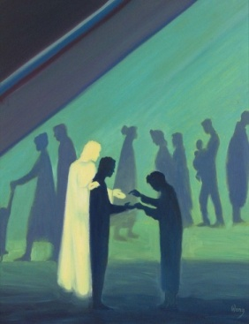

|  |
| --- |
| **At Home**  You could help your children by:  • visiting [www.tere.org/interactive_site/KS2link](http://www.tere.org/interactive_site/KS2link)  • reading the story of Pentecost with them and discussing how the apostles changed  •discussing what they have learned about the Holy Spirit and how they can apply this to life |