It is with great pleasure that I write to tell you about our achievements this year. Across the board the children have performed amazingly well and we are incredibly proud of both their efforts and their progress.

I am very proud of the hard work and dedication of the whole staff and especially the children. We have worked relentlessly since our last Ofsted inspection to improve standards and to achieve these results.

Early Year Foundation Stage End of Year outcomes 2015
2015 - 69% achieved a good level of development, a 5% increase since last year and 8% above that achieved nationally last year.

Phonics Screening Check Results
National 2014 | % school 2015 | % school 2014 | % school 2013 | % school 2012 | 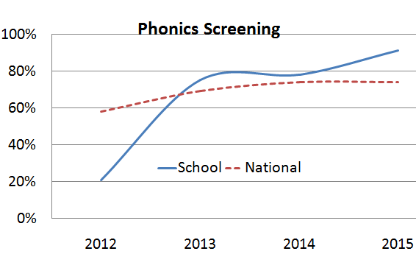
74% | 91% | 78% | 75% | 21%

Substantial progress has been made since 2012. Year 1 phonics screening check shows a 13% increase in phonics on 2014 school results and a 16% increase on 2013 results. The outcome is 17% above the 2014 national result (74%). 100% of the children retaking the phonics screening test in Y2 passed.

KS1 End of Year Assessments 2015
Key Stage 1 results highlight substantial progress since 2013 with this progress being sustained in 2015.
Subject | Level | School 2014 % | School 2015 % | 2014 % national | School 2013 % | School 2012 %
Reading | L3 | 20% | 32% | 31% | 23% | 5%
 | L2b+ | 83% | 93% | 81% | 70% | 67%
 | L2+ | 97% | 97% | 90% | 87% | 85%
Writing | L3 | 8% | 15% | 16% | 0 | 0
 | L2b+ | 73% | 76% | 70% | 52% | 45%
 | L2+ | 97% | 90% | 86% | 75% | 78%
Maths | L3 | 22% | 29% | 24% | 12% | 2%
 | L2b+ | 85% | 92% | 81% | 78% | 63%
 | L2+ | 93% | 97% | 92% | 88% | 91%
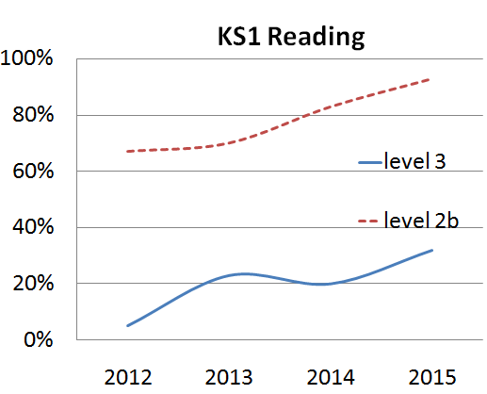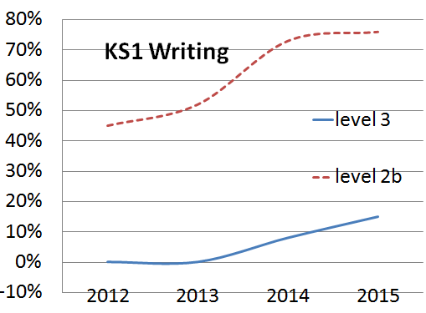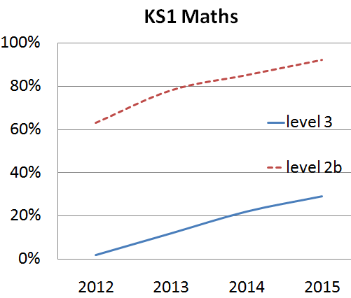

KS2 results
Progress in KS2 has been outstanding since 2012.
READING | 3 + | 4 + | 4b+ | 5 +
School (2015) | 95% | 93% | 88% | 53%
National (2014) | 95% | 89% | 78% | 49%
School (2014) | 95% | 90% | 81% | 47%
School (2013) | 95% | 86% | 67% | 38%
School (2012) | 94% | 85% |  | 31%
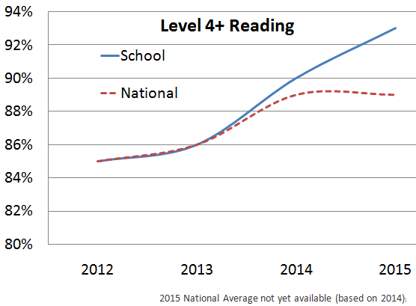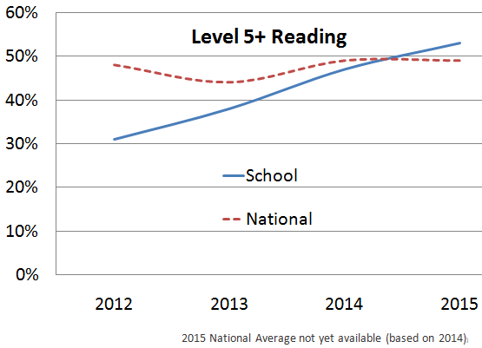

WRITING | Level 3 + | Level 4 + | Level 5 + | Level 6
School (2015) | 97% | 95% | 51% | 3%
National (2014) | 96% | 85% | 33% | 2%
School (2014) | 98% | 97% | 36% | 5%
School (2013) | 95% | 69% | 9% | 0%
School (2012) | 90% | 63% | 4% | 0%
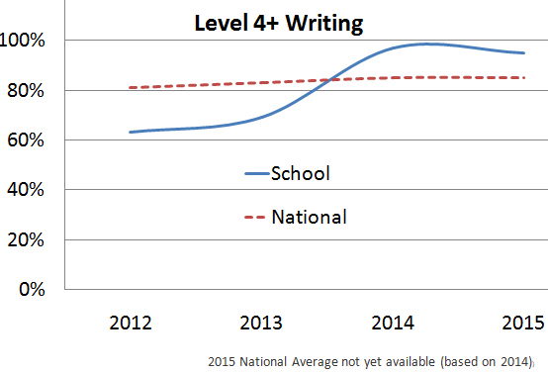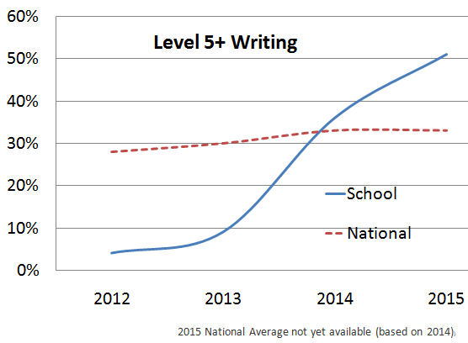

MATHS | Level 3+ | Level 4+ | Level 4B+ | Level 5+ | Level 6
School (2015) | 97% | 92% | 76% | 42% | 10%
National (2014) | 96% | 86% | 76% | 42% | 9%
School (2014) | 98% | 91% | 88% | 50% | 16%
School (2013) | 95% | 83% | 71% | 33% | 0%
School (2012) | 94% | 77% |  | 21% | 0%
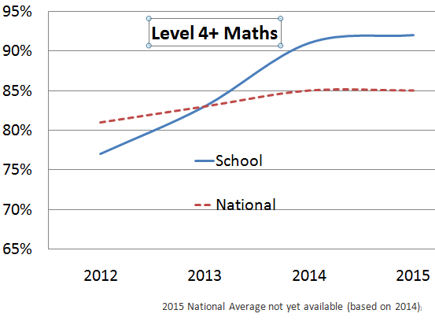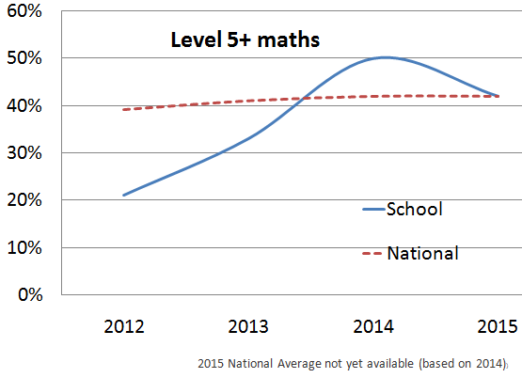
Thank you for supporting children at home. This has contributed hugely to our achievements.
GPs | Level 3+ | Level 4+ | Level 4B+ | Level 5+ | Level 6
School (2015) | 97% | 93% | 88% | 71% | 3%
National (2014) | 94% | 76% | 52% | 52% | 4%
School (2014) | 95% | 83% | 59% | 59% | 7%
School (2013) | 54% | 41% | 38% | 27% | 0%

