Worship Together - Aspire Together- Excel Together

INSET DAY Friday 19th October 2018 – School closed to pupils
Half Term Holiday Monday 22nd – Friday 26th October
Pupils return to school Monday 29th October

Head Teacher’s Message - We have completed our first half term, it has been a very busy term and the children have all settled back, a warm welcome to new pupils that have joined English Martyrs’
Month of the Rosary - The month of the Holy Rosary is October and the entire month is dedicated to the Rosary. The feast of the Rosary is held in memory of the glorious and triumphant victory at the battle of Lepanto. The Rosary is being held for children in both school buildings each morning at 8.30am.
School Fund Contributions - We are asking parent/guardians for an annual £10.00 per family contribution towards school trips and visitors. This helps infuse and deepen children’s’ understanding of topics taught and helps enrich their learning opportunities. Letters will be sent to parents after the half term.
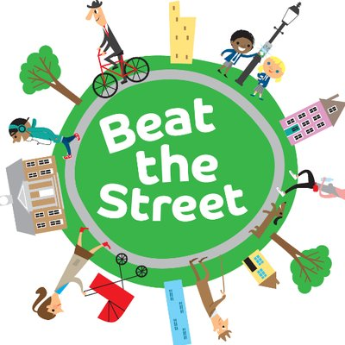
Beat the street All staff and pupils at English Martyrs’ are very excited to be taking part in Beat the Street. This is an initiative organised by Southwark Council that involves tapping in to some set points around the borough using a special fob key. Every child has been given a fob and parent a card in a letter explaining the initiative. Each time that someone taps in with their fob, an automatic counter clocks up our score. We are competing in a friendly game of Beat the Street with most other Southwark schools throughout the borough. Forty-five outdoor locations are in place around Southwark. These are all in safe areas away from traffic. The main aim is to get people to explore their borough and to be active and fit outdoors.
This game of Beat the Street will take place over a seven week period. The winner will be the school that achieves the highest number of swipes at a beat box during this period. It is very early days, but EMS is currently in 3rd on the leader board! Prizes will be presented at the end of the seven week period for the winning teams. We would like to encourage all parents and carers to take part in Beat the Street whenever you are out and about around the borough. You can swipe the boxes at weekends and during the half term holiday.
Year 6 Residential 2019 - This year we have chosen to go to Grosvenor Hall, Ashford from 6th February - 8th February 2019. The site is very impressive and children will take part in 11 activities during their stay. This may include: archery, zip wire, aero ball, low ropes, blind trail, team tasks, football, basketball, cinema etc. The centre is run by fully qualified and experienced staff, which have many years of experience working with children of all ages and children will be accompanied by Y6 staff. This trip offers the children the chance to experience genuine outdoor education and have life experiences with real learning outcomes. It allows us to teach the children skills that we cannot do in the classroom, focusing on team building in particular and prepares them for independence in decision making in secondary school. Some pupils have paid their deposit but please hurry, if you have any questions please do not hesitate to speak to a member of the Year 6 teaching team.

School Photographer – The School photographer will be in school on 7th November to take individual and class photos. This year siblings’ photographs will be taken. Please ensure your child is in full school uniform.
Dates to remember - Please have a look at dates for October and planned events.

2nd October | Flu vaccinations for Rec, Yr 1 – Year 5
3rd October | Girls Football taster session
4th October | Year 5 and 6 – Girls boxing taster session
9th October | Year 3 Golden Hinde Pirates boat workshop and trip
9th October | Year 6 Tower of London Crime and Punishment Trip
10th October | Year 5 and 6 Tower of London Crime and Punishment Trip
11th October | Year 5 and 6 Tower of London Crime and Punishment Trip
12rh October | Year 5 We Feed The World (Food matters) workshop and trip
15th October | Rec, Yr 1 and 2 - Author Visit - Joseph Coelho and illustrator Fiona Lumbers – “Luna Loves Library”
16th October | African Dancing – Nur, Rec, Yr 1 and 2, parents invited to performance
17th October | Celebrating Black History Month – International Day – pupils wear their own traditional clothes
19th October | Inset Day – School closed to pupils
Good Luck – Ms Piesse – Reception class assistant will be starting her maternity leave after the half term, we wish her all the very best and welcome her baby boy into our EMS family. Sending her God’s blessing

After School Club provision - English Martyrs’ is currently looking into an external after school club provision for parents/Guardians. We have been working in partnership with Fit for Sport whom currently provides our P.E. lessons and can also offer the school after school provision, this will be run by Fit for Sport and payment will be made through them. They will only be using our school facilities to host the club. A parent survey was sent to parents so please check your child’s school bags and we ask if you would complete the survey if you are interested in after school care for your child/ren and return to the school office.

Half term Activities
There are many exciting activities on offer through Southwark to keep you and your children busy in the holidays, visit Southwark website for more information.
Please support your child’s learning at home with listening to them read each evening and logging on to their MyMaths.

God Bless, Mrs Appah

