Alphabet game:
Find an object in your house that starts with a letter A all the way to Z.
Time how fast it takes you to get the object and bring it to your starting position.
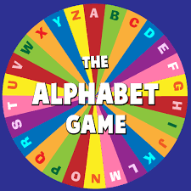
If you cannot find an object with the letter you do 10 star jumps and move to the next letter.

