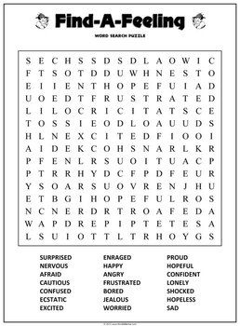
Find the words in the word search you can make this into a challenge and see how many you can find in 3 minutes.

