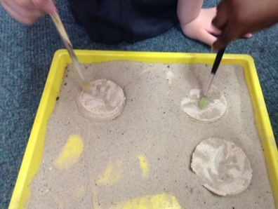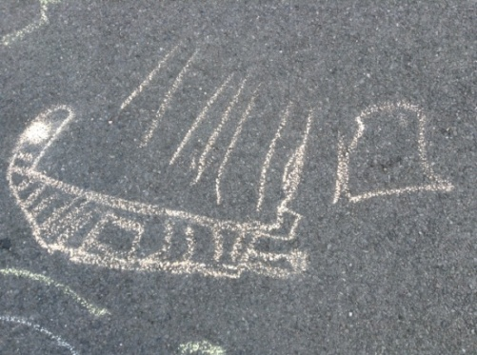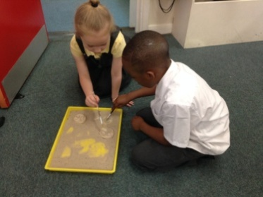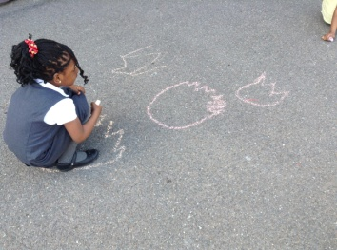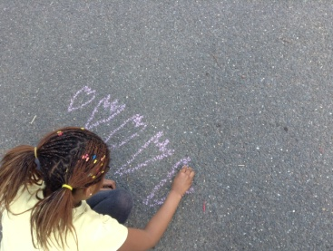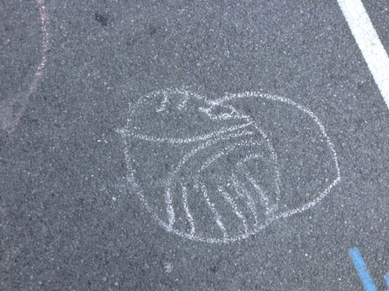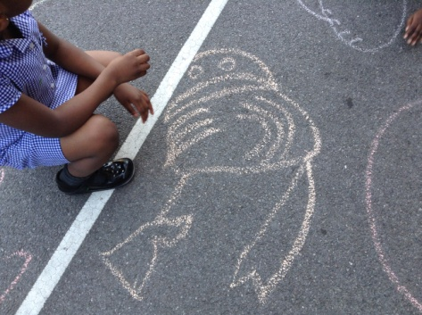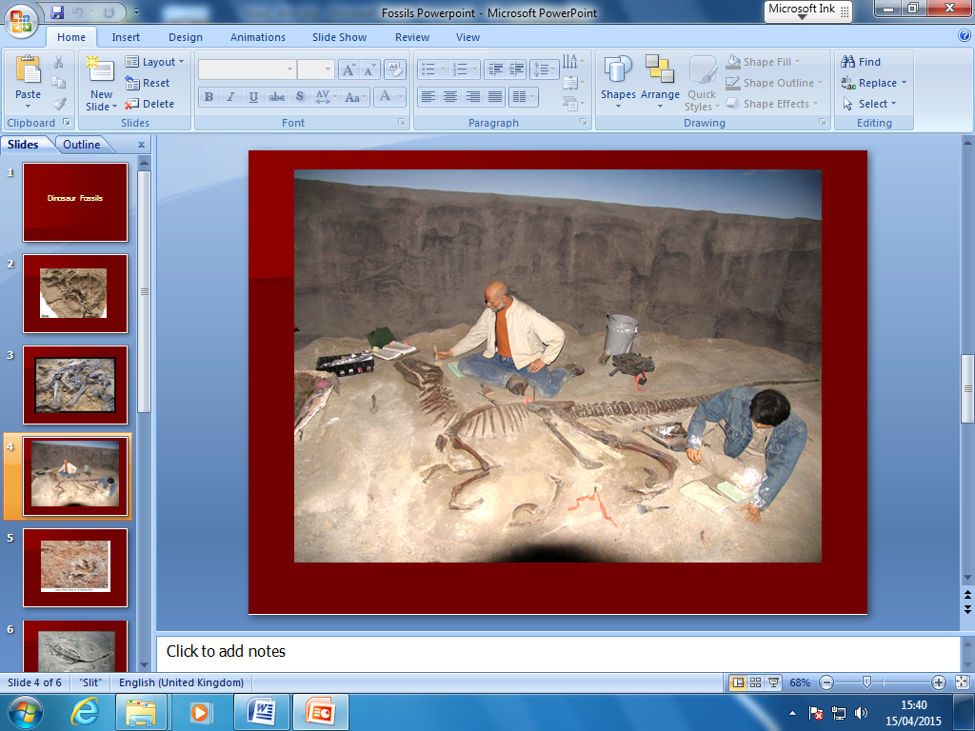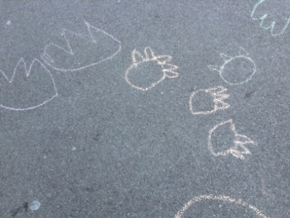[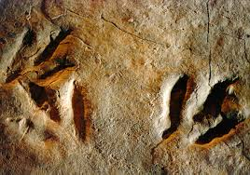](http://www.google.co.uk/imgres?imgurl=http://www.albany.edu/~jdelano/footpr.jpg&imgrefurl=http://www.albany.edu/~jdelano/footpr.html&h=304&w=432&tbnid=0Bw0cYynscXYDM:&zoom=1&docid=nFwqRmOUG_vPdM&hl=en&ei=JXsuVYbzFofpaKeGgLgC&tbm=isch&ved=0CBYQMygOMA44yAE)[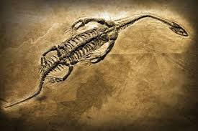](http://www.google.co.uk/imgres?imgurl=http://www.scienceclarified.com/photos/fossil-and-fossilization-2867.jpg&imgrefurl=http://www.scienceclarified.com/Ex-Ga/Fossil-and-Fossilization.html&h=280&w=420&tbnid=nZPo7LIr6tcsgM:&zoom=1&docid=nC7Dpa6sj9h__M&ei=OXouVf7-B8Pfat7SgegJ&tbm=isch&ved=0CFMQMygXMBc)

We are

Palaeontologists!

We found footprints.

We investigated fossils.