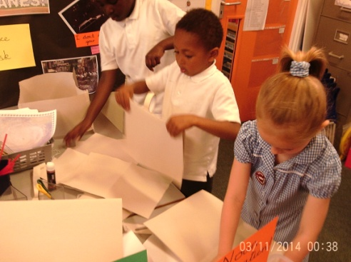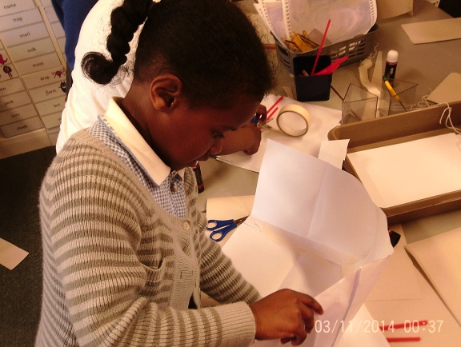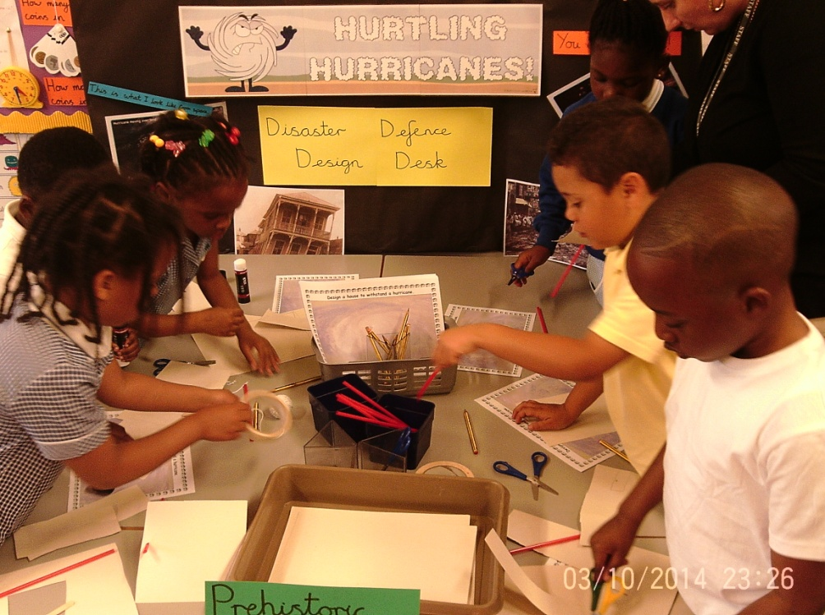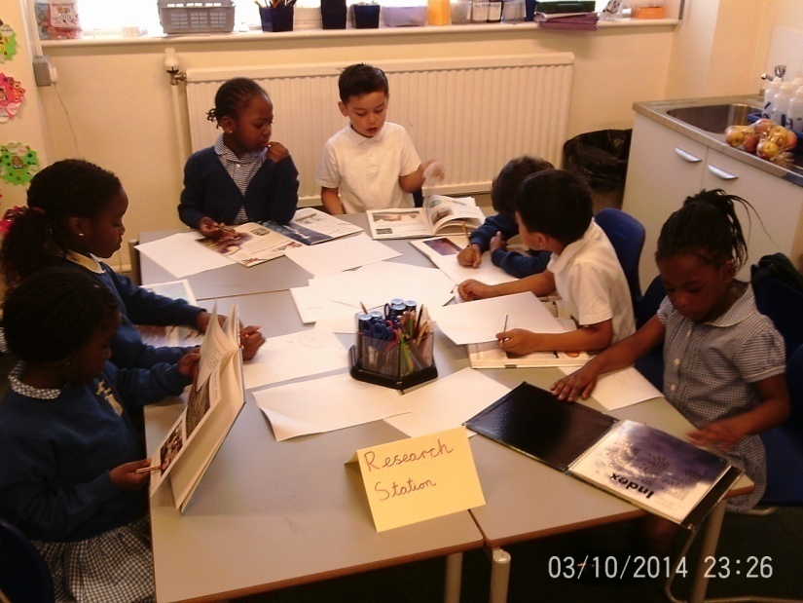

**BUILDING A HURRICANE SHELTER!**

Then we designed our hurricane shelters.

Next we built a model shelter.

First we did some research.

[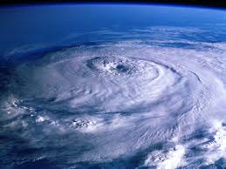](http://www.google.co.uk/url?sa=i&rct=j&q=&esrc=s&source=images&cd=&cad=rja&uact=8&ved=0CAcQjRw&url=http://globe-views.com/dreams/hurricane.html&ei=QeGLVarVFM6v7AbzhbdQ&bvm=bv.96782255,d.ZGU&psig=AFQjCNHMh5TE3GrRvD_Ewfxydab6cYlgKw&ust=1435316925876281)[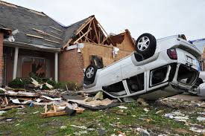](http://www.google.co.uk/imgres?imgurl=http://www.publicadjustersassociates.com/images/tornado-damages.jpg&imgrefurl=http://www.publicadjustersassociates.com/Hurricane-Damage-PA-NJ.php&h=419&w=630&tbnid=VQQZQJvRILb2IM:&zoom=1&docid=dHIAKEuR_RTD3M&hl=en&ei=ZuGLVcqMKeqP7Aa-37uIAQ&tbm=isch&ved=0CCkQMygKMAo)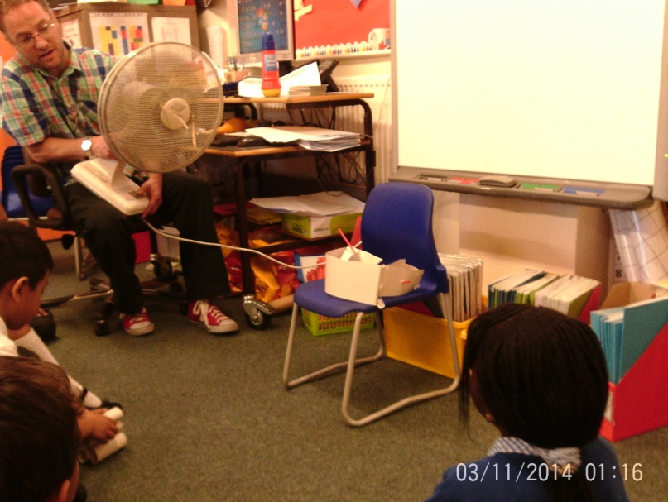

Oops!

Finally we tested our designs!