Indoor bowling with water bottles or cartons of empty drinks (as pins) you can number the bottles if you want.
Socks or a small ball, as a bowling ball.
You can compete with siblings or parents
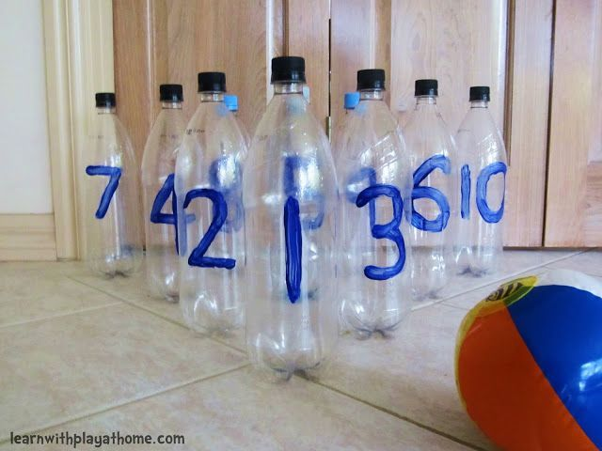
Challenge yourself everyday for the week to see if you get better and write down how many times it takes you to knock all the bottles down.

