Roll a dice and follow the maze and try to get to the finish point
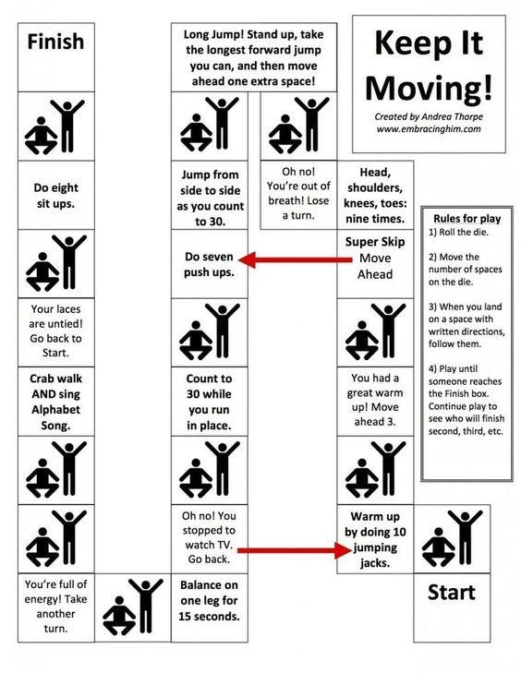
If you don’t have a dice make your own with a piece of paper.

